**LEARNHUB: YOUR CENTER FOR SKILL ENHANCEMENT**

**1. Introduction**

**Project Title:** LearnHub: Your Center For Skill Enhancement

**Team ID:** LTVIP2025TMID20294

**Team Members & Roles:**

1. **Gundiga Lahari** – Team Leader, Full Stack Developer
2. **Gudipudi Lakshmi Sailaja** – Backend Developer
3. **Gudapati Siri** – Frontend Developer
4. **Gubbala Harini** – UI/UX Designer & Frontend Support

**2. Project Overview**

**Purpose:**

The goal of LearnHub is to create a scalable, user-friendly e-learning platform that empowers learners and educators. The application facilitates online course registration, course creation, progress tracking, and certification.

**Features:**

1. **User-Friendly Interface:** Online learning platforms typically have an intuitive and user-friendly interface that makes it easy for learners, regardless of their technical proficiency, to navigate and access the content.
2. **Course Management:** Instructors or course creators can upload, organize, and manage course materials. Learners can enroll in courses and track their progress.
3. **Interactivity:** Many platforms include interactive elements like discussion forums, chat rooms, and live webinars, which foster communication and collaboration among learners and instructors.
4. **Certification:** Learners can earn certificates or badges upon completing courses or meeting certain criteria, which can be valuable for employment or further education.
5. **Accessibility:** Content is often accessible on various devices, including computers, tablets, and smartphones, making learning possible from anywhere with an internet connection.
6. **Self-Paced Learning:** Learners can typically access course materials at their own pace. This flexibility allows for learning that fits into individual schedules and preferences.
7. **Payment and Subscription Options**: There may be free courses, but some content may require payment or a subscription. Platforms often offer multiple pricing models.

**3. Architecture**

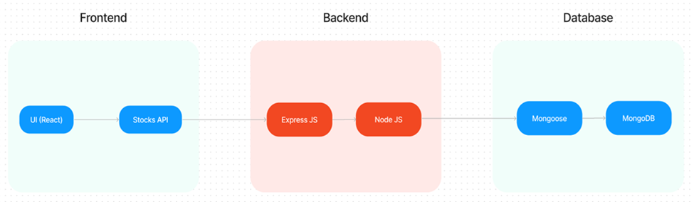

The technical architecture of OLPapp follows a client-server model, where the frontend serves as the client and the backend acts as the server. The frontend encompasses not only the user interface and presentation but also incorporates the axios library to connect with backend easily by using RESTful APIs.

The front end utilizes the bootstrap and material UI library to establish a real-time and better UI experience for any user.

On the backend side, we employ Express.js frameworks to handle the server-side logic and communication.

For data storage and retrieval, our backend relies on MongoDB. MongoDB allows for efficient and scalable storage of user data and necessary information about the place.

Together, the frontend and backend components, along with Express.js, and MongoDB, form a comprehensive technical architecture for our OLPapp. This architecture enables real-time communication, efficient data exchange, and seamless integration, ensuring a smooth and immersive blogging experience for all users.

**4. Setup Instructions**

**Pre-requisites**

Here are the key prerequisites for developing a full-stack application using Node.js, Express.js, MongoDB, and React.js:

✔**Vite:**

Vite is a new frontend build tool that aims to improve the developer experience for development with the local machine, and for the build of optimized assets for production (go live).

**npm create vite@latest**

✔**Node.js and npm:**

Node.js is a powerful JavaScript runtime environment that allows you to run JavaScript code on the server side. It provides a scalable and efficient platform for building network applications.

Install Node.js and npm on your development machine, as they are required to run JavaScript on the server side.

Download: <https://nodejs.org/en/download/>

Installation instructions: <https://nodejs.org/en/download/package-manager/>

**npm init**

✔**Express.js:**

Express.js is a fast and minimalist web application framework for Node.js. It simplifies the process of creating robust APIs and web applications, offering features like routing, middleware support, and modular architecture.

Install Express.js, a web application framework for Node.js, which handles server-side routing, middleware, and API development.

Installation: Open your command prompt or terminal and run the following command:

**npm install express**

✔**MongoDB:**

MongoDB is a flexible and scalable NoSQL database that stores data in a JSON-like format. It provides high performance, horizontal scalability, and seamless integration with Node.js, making it ideal for handling large amounts of structured and unstructured data.

Set up a MongoDB database to store your application's data.

Download: <https://www.mongodb.com/try/download/community>

Installation instructions: <https://docs.mongodb.com/manual/installation/>

✔**React.js:**

React.js is a popular JavaScript library for building user interfaces. It enables developers to create interactive and reusable UI components, making it easier to build dynamic and responsive web applications.

Install React.js, a JavaScript library for building user interfaces.

Follow the installation guide: <https://reactjs.org/docs/create-a-new-react-app.html>

✔**HTML, CSS, and JavaScript**: Basic knowledge of HTML for creating the structure of your app, CSS for styling, and JavaScript for client-side interactivity is essential.

✔**Database Connectivity**: Use a MongoDB driver or an Object-Document Mapping (ODM) library like Mongoose to connect your Node.js server with the MongoDB database and perform CRUD (Create, Read, Update, Delete) operations. To Connect the Database with Node JS go through the below provided link:

[https://www.section.io/engineering-education/nodejs- mongoosejs-mongodb/](https://www.section.io/engineering-education/nodejs-%20mongoosejs-mongodb/)

**Install Dependencies:**

• Navigate into the cloned repository directory:

cd learnhub

• Install the required dependencies by running the following commands:

cd frontend

npm install

cd ../backend

npm install

Start the Development Server:

• To start the development server, execute the following command:

npm start

• The LearnHubapp will be accessible at [http://localhost:517](http://localhost:5172/)3

You have successfully installed and set up the Online learning app on your local machine. You can now proceed with further customization, development, and testing as needed.

**5. Folder Structure**

|  |  |
| --- | --- |
| Frontend / Client | Backend / Server |
|  |  |

**6. Running the Application**

Frontend: Run `npm run dev` in the frontend directory.  
Backend: Run `node index.js` in the backend directory.

App runs at: <http://localhost:5173>

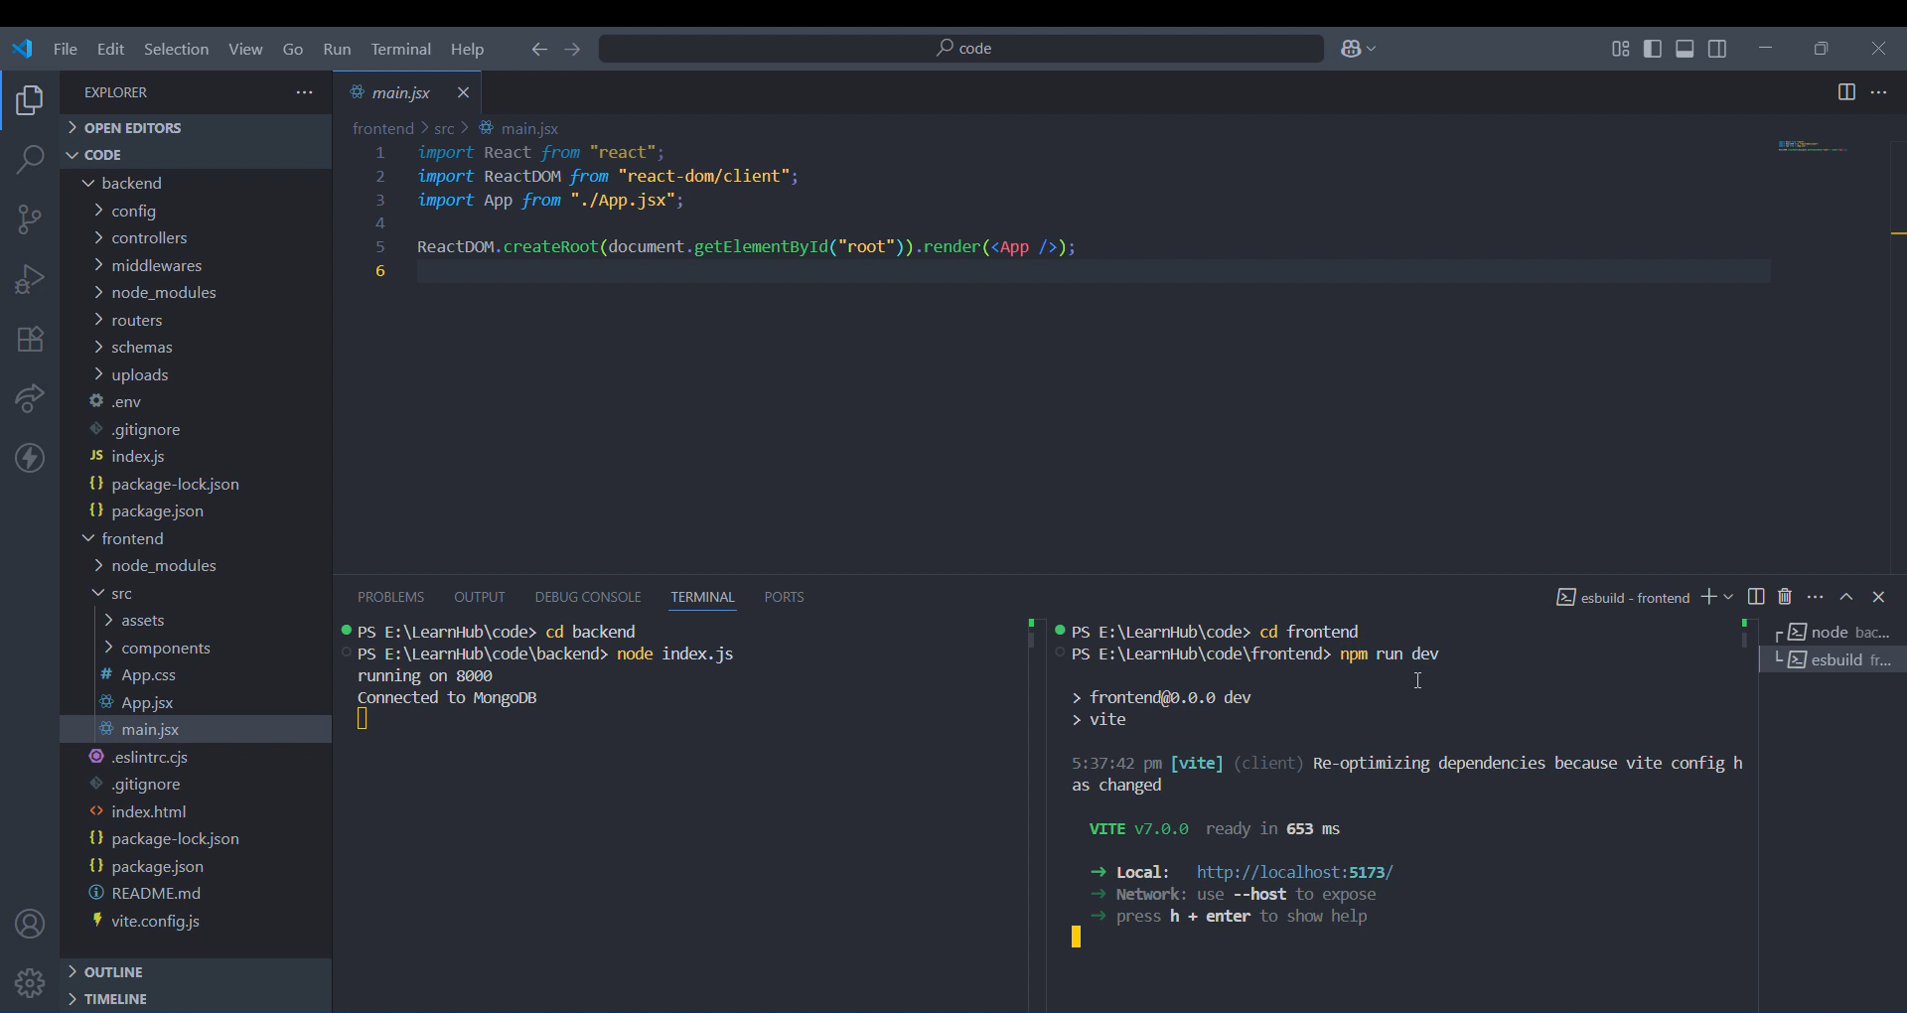

**7. API Documentation**

**Authentication**

* POST /api/register – Register user
* POST /api/login – Login user

**Courses**

* GET /api/courses – Get all courses
* POST /api/courses – Create new course
* PUT /api/courses/:id – Update course
* DELETE /api/courses/:id – Delete course

**8. Authentication**

JWT-based authentication. Tokens stored in localStorage. Protected routes use middleware. Passwords hashed using bcrypt.

**9. User Interface**

Clean and responsive UI with Bootstrap and CSS. Screens include Home, About, Login, Register, Course Details, and Dashboard.

**10. Testing**

Manual testing done using dummy data. APIs tested with Postman. Future scope includes unit testing with Jest.

**11. Screenshots or Demo**

Home Page

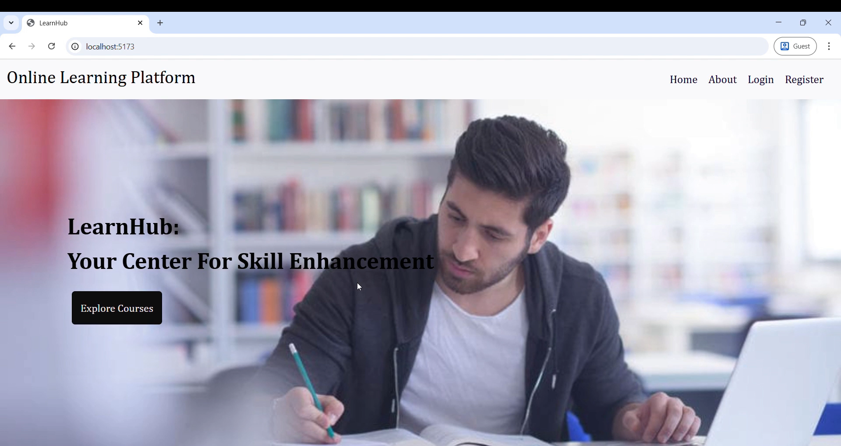

About Page

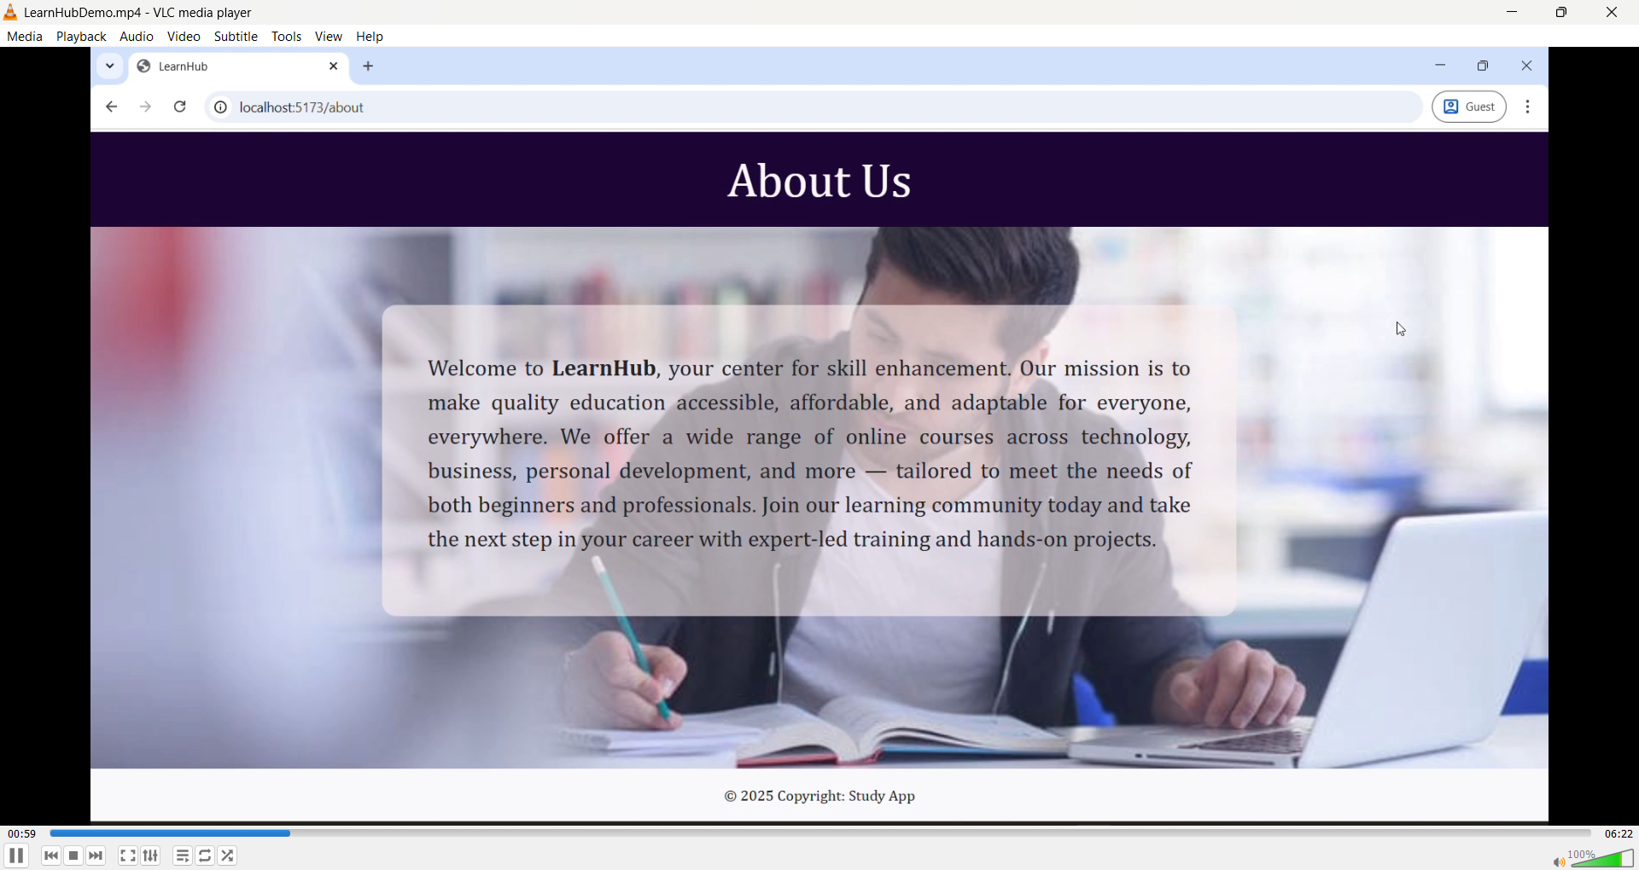

Registration Page

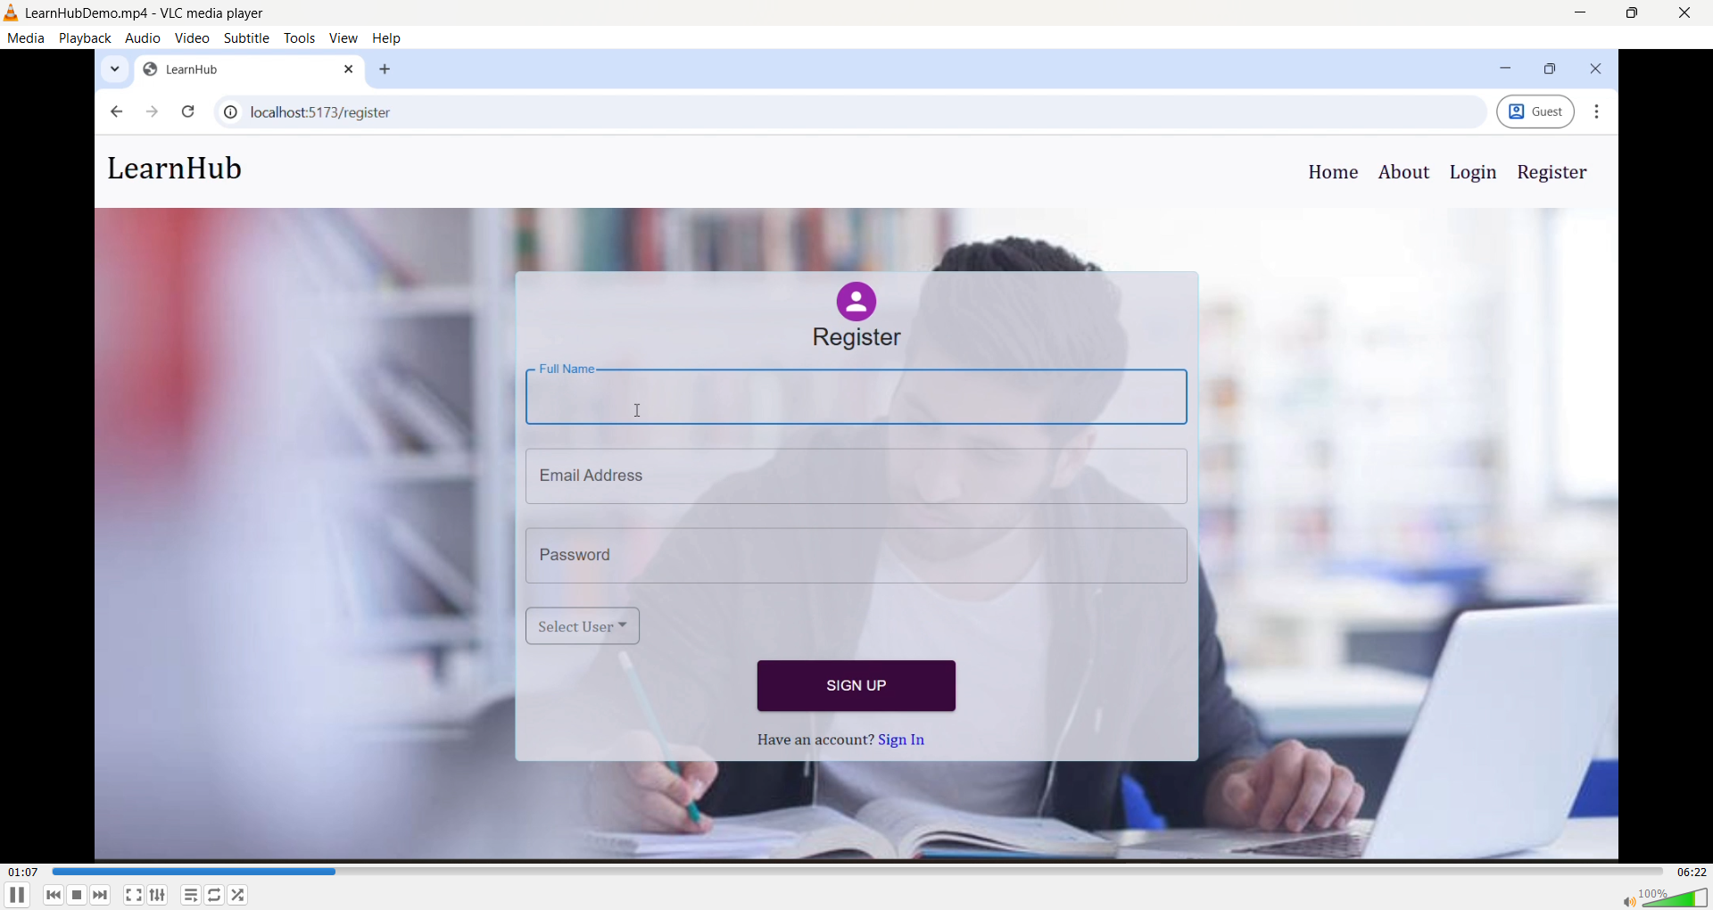

Login Page

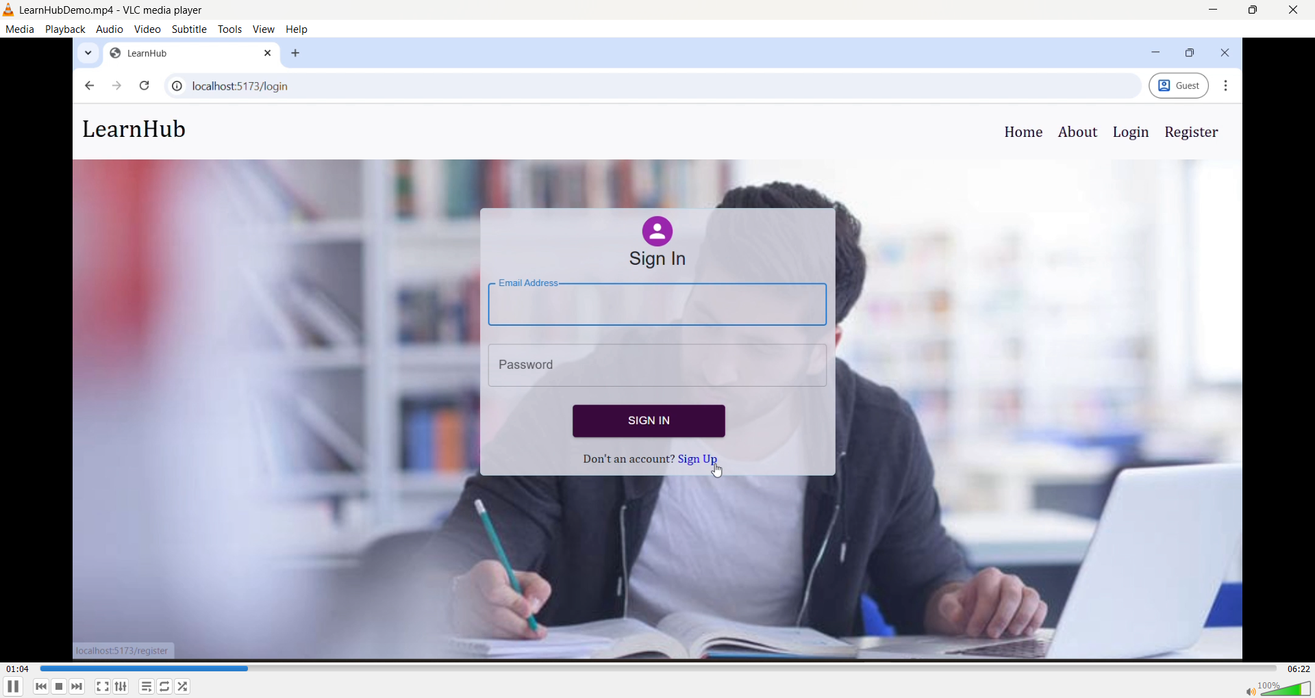

User can register as teacher or student

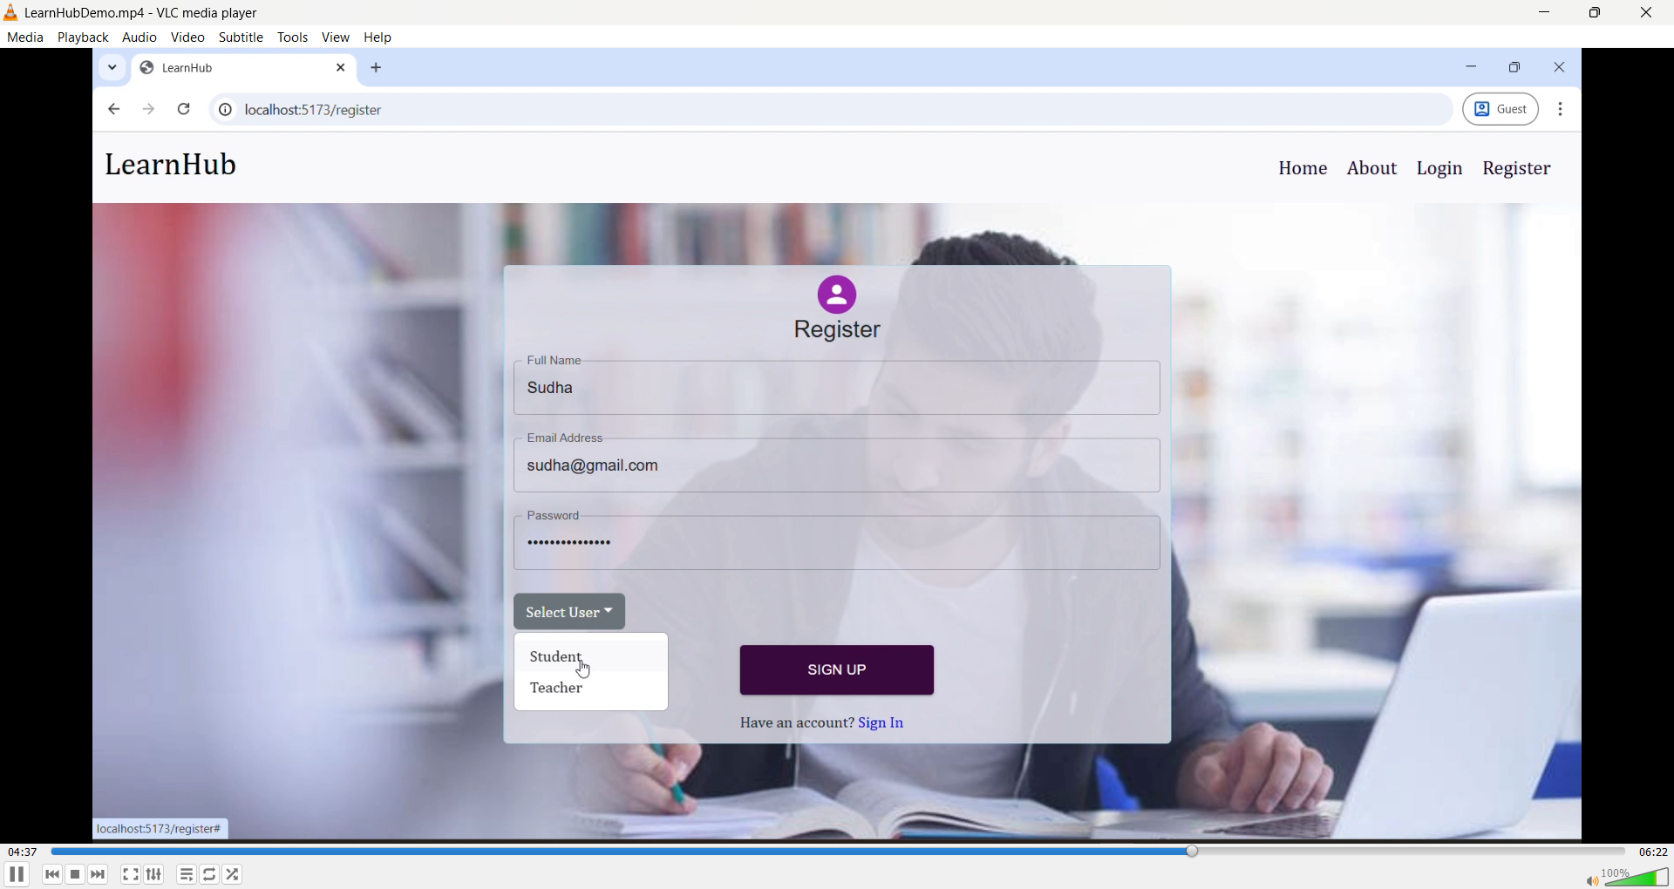

Teacher Dashboard

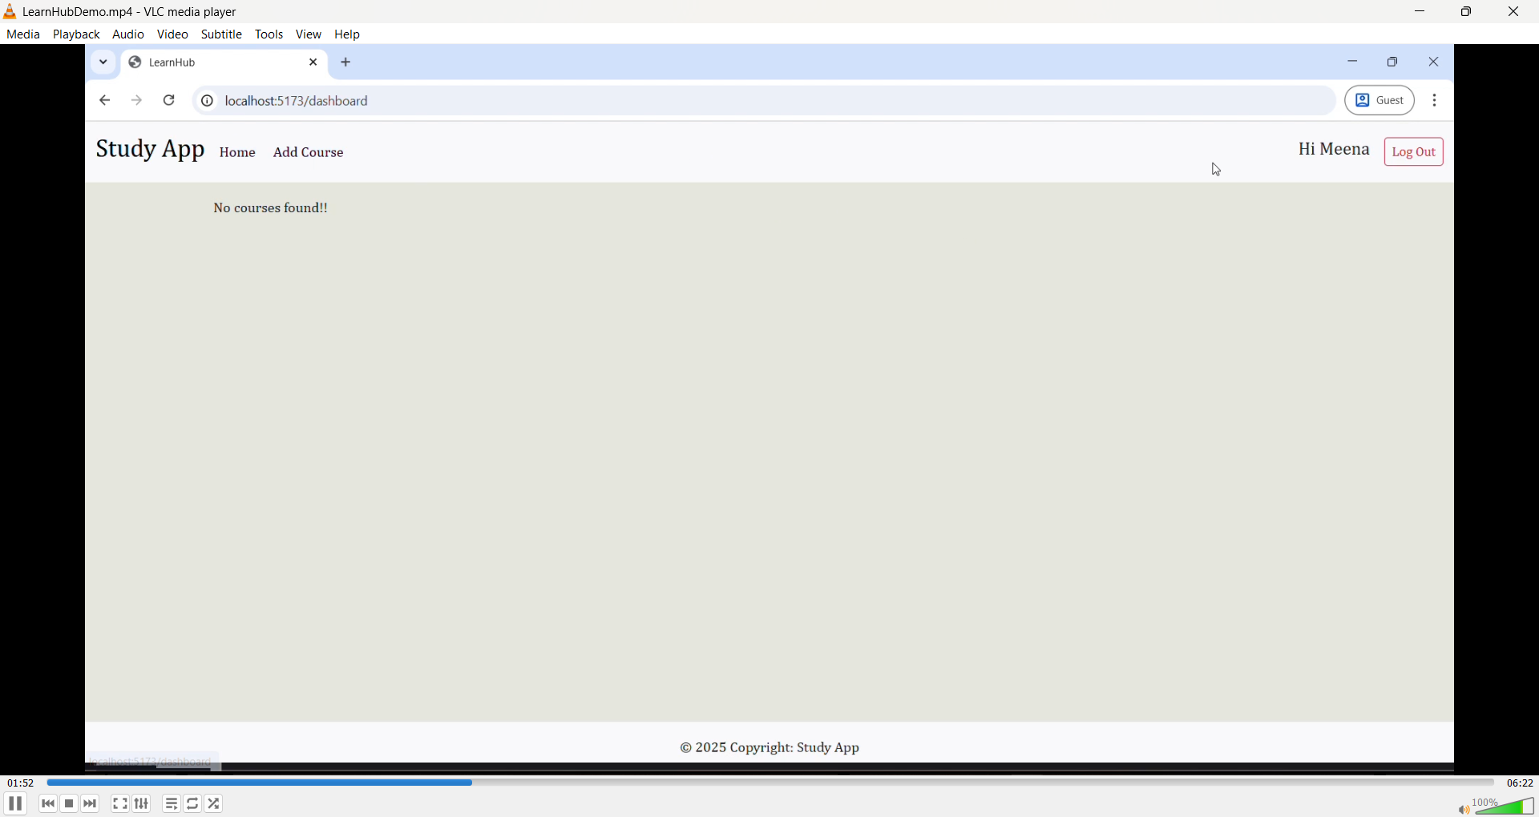

Adding a course

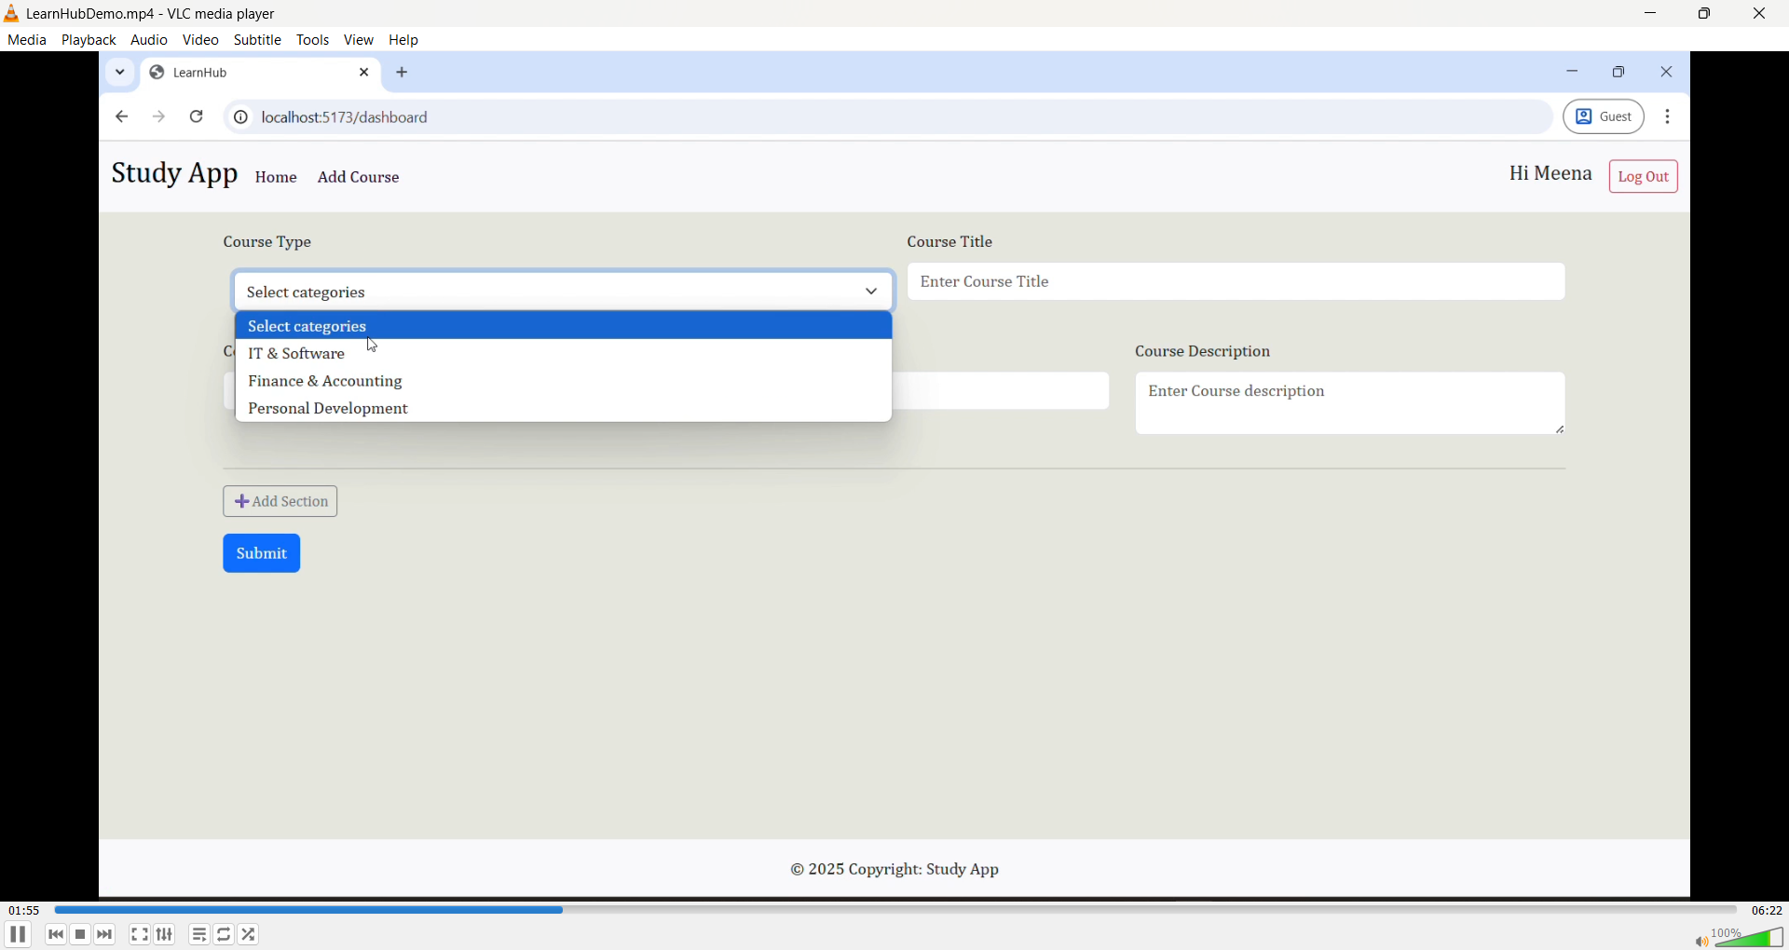

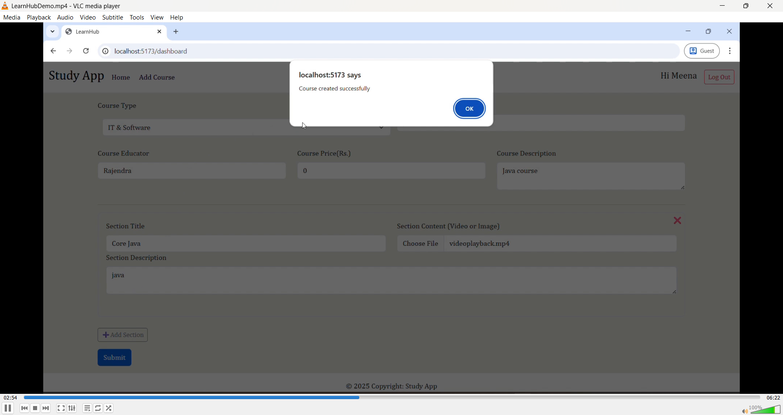

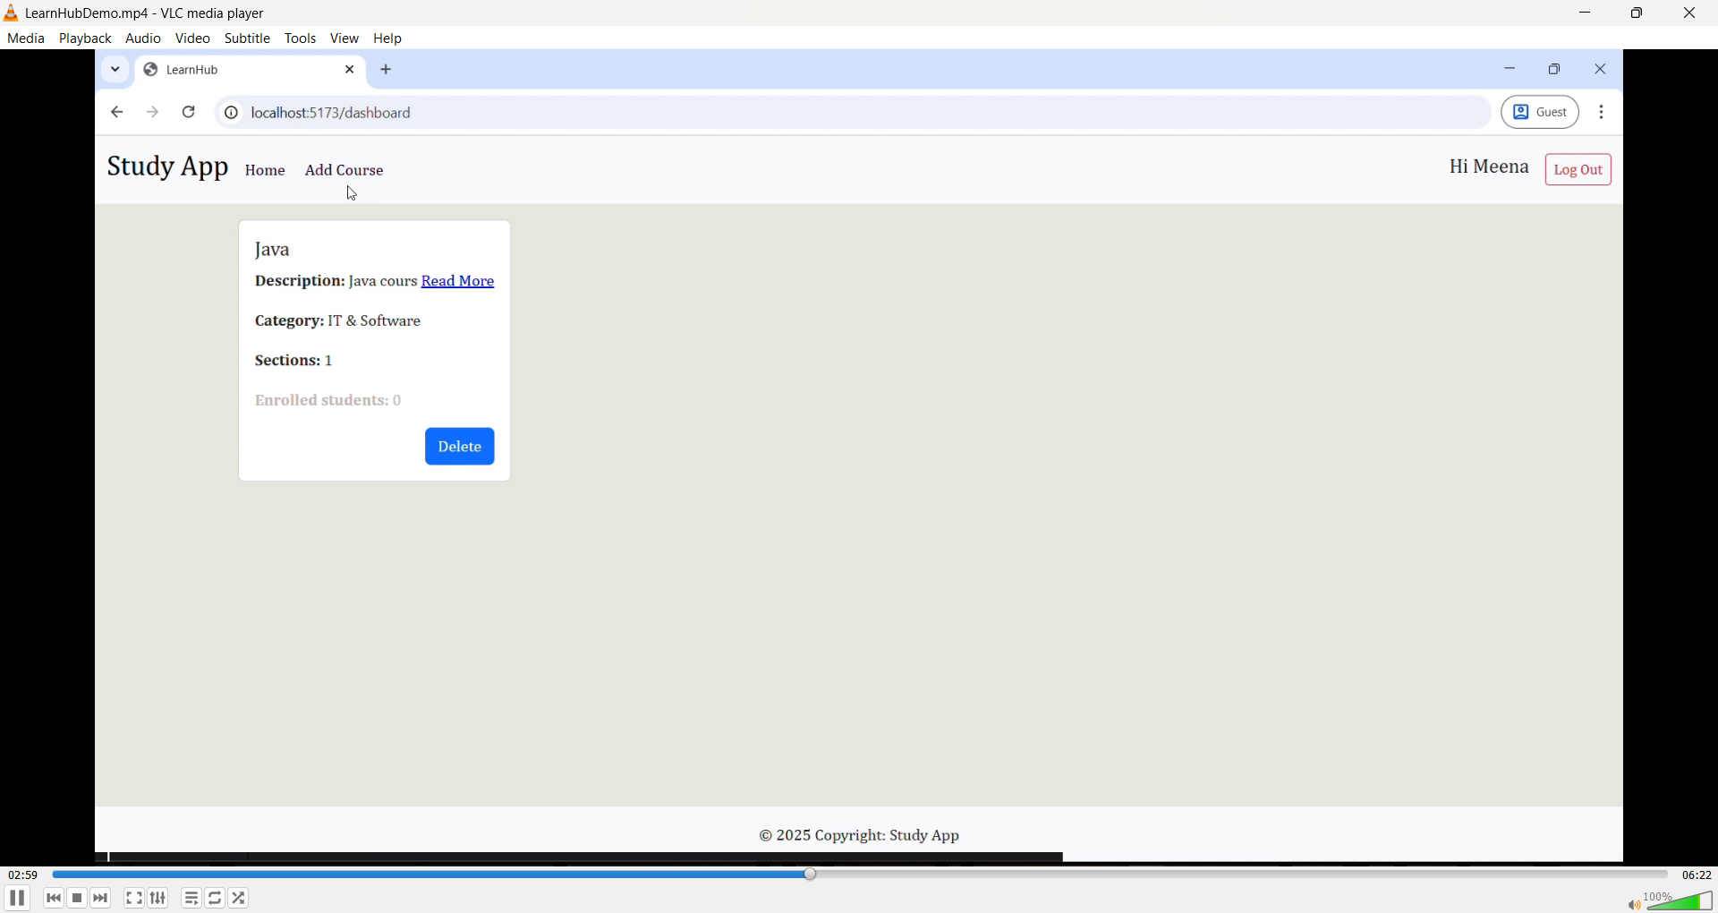

Student Dashboard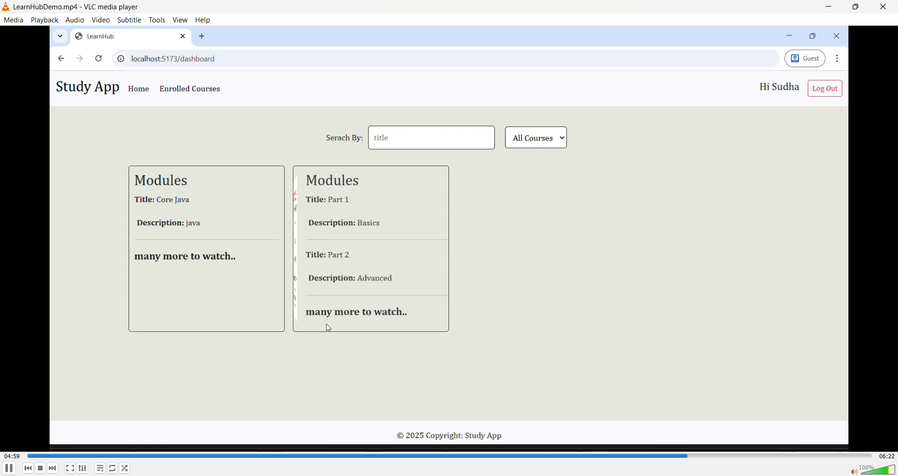

Buying the Course

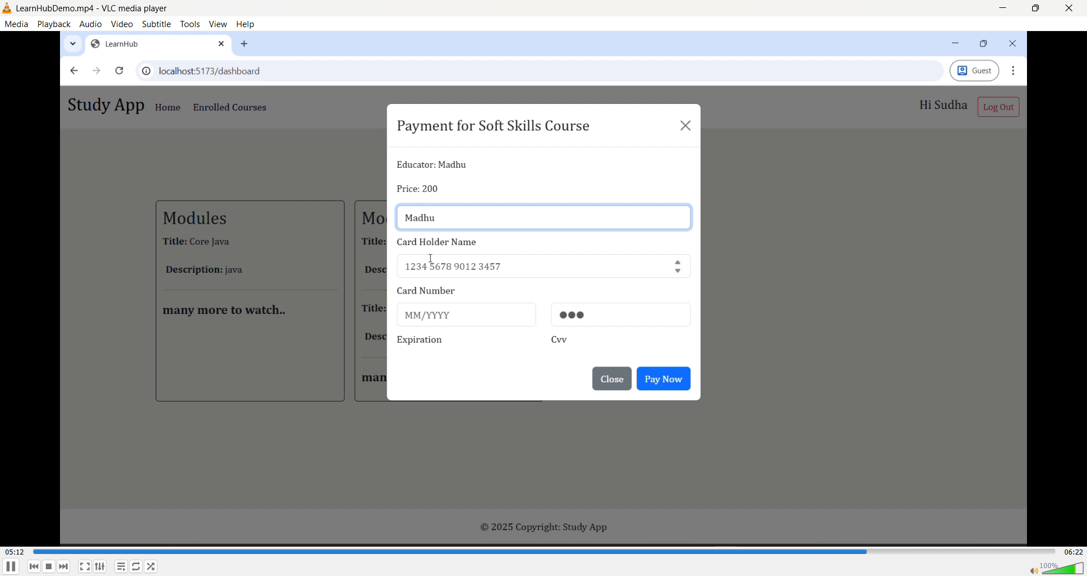

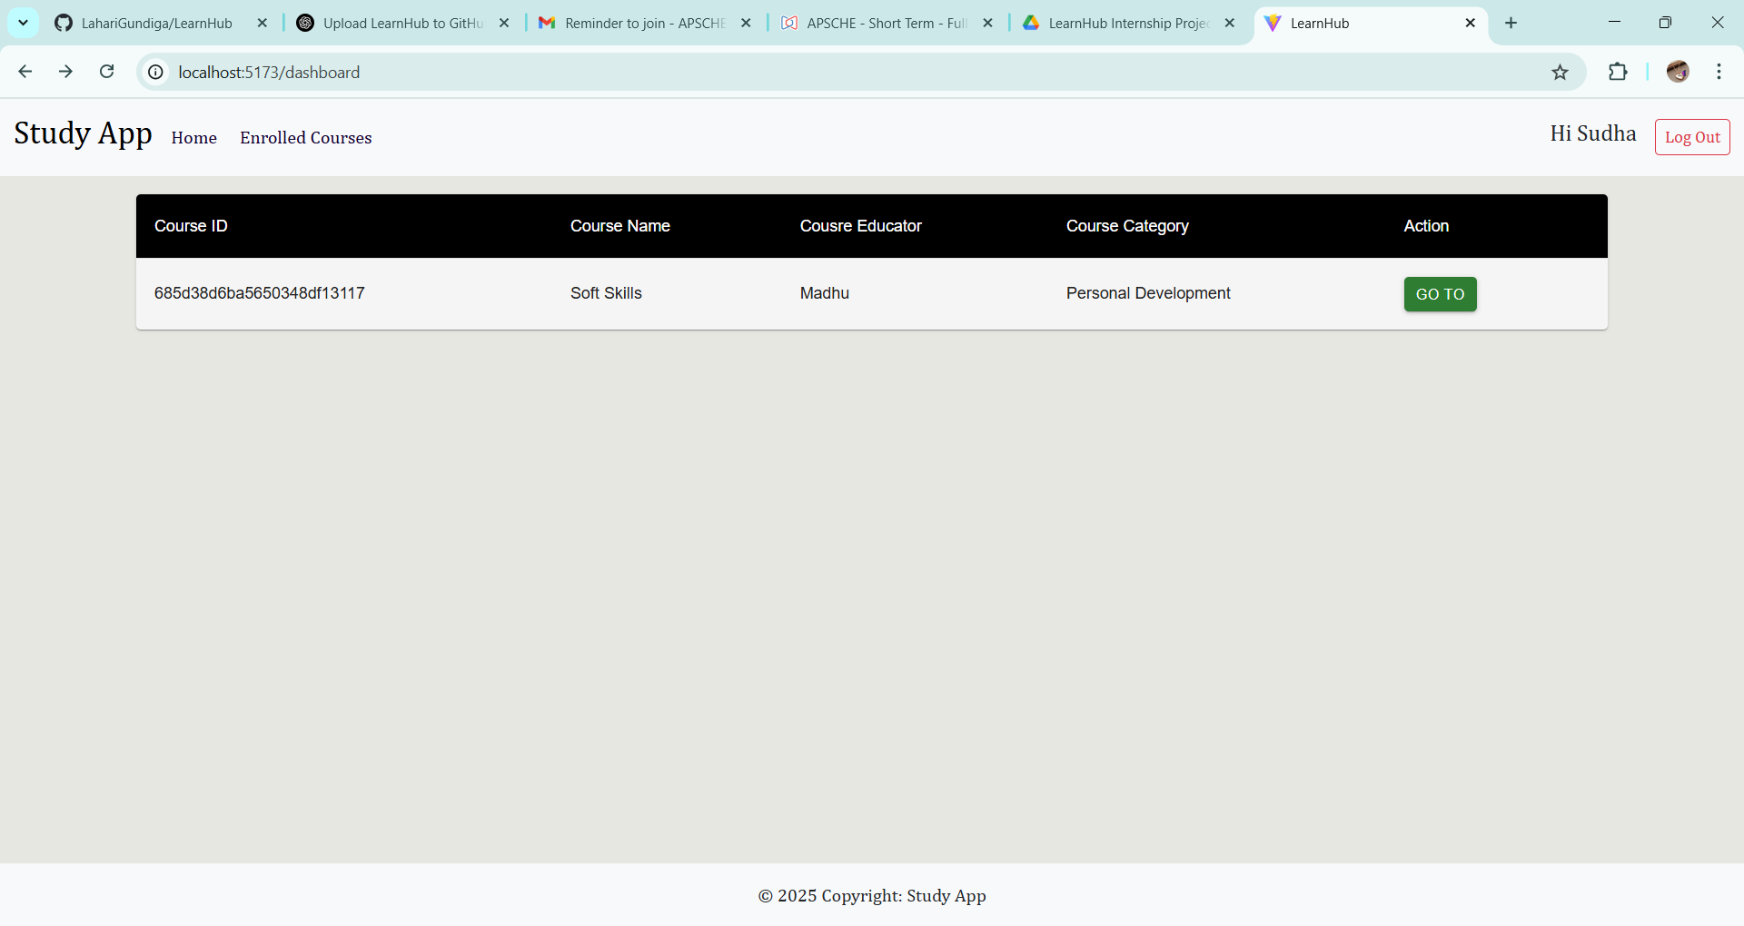

Accessing the course

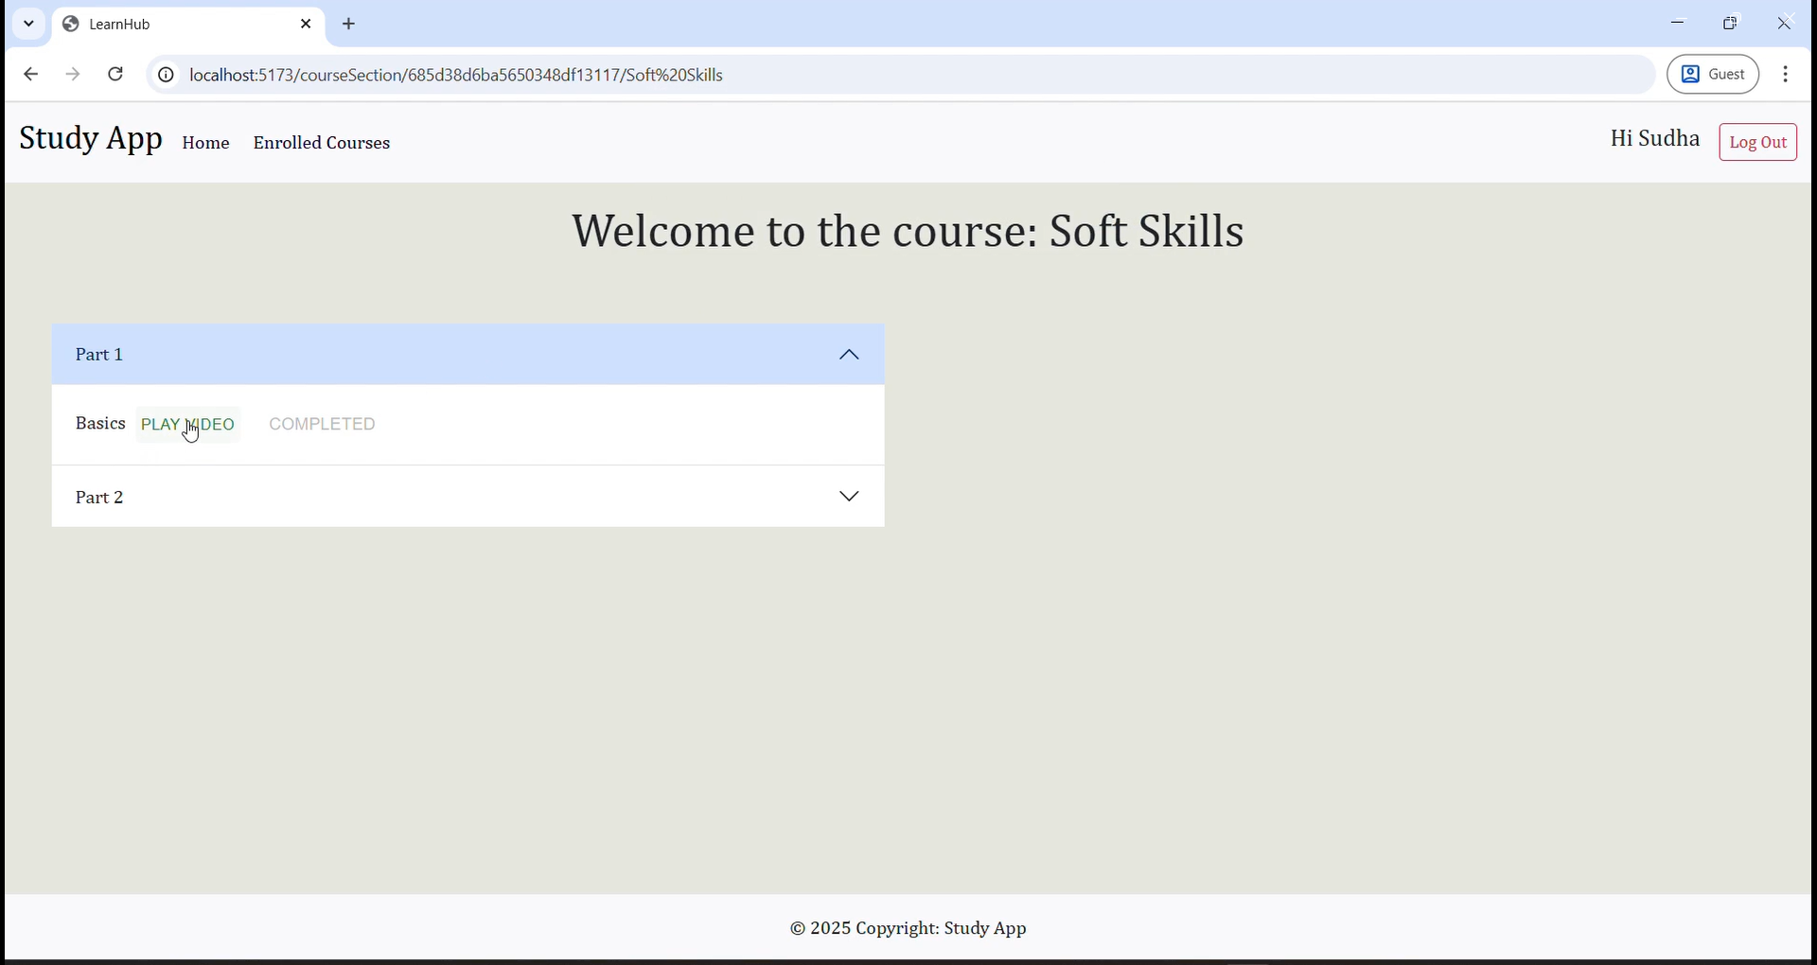

Certificate on completion of the course

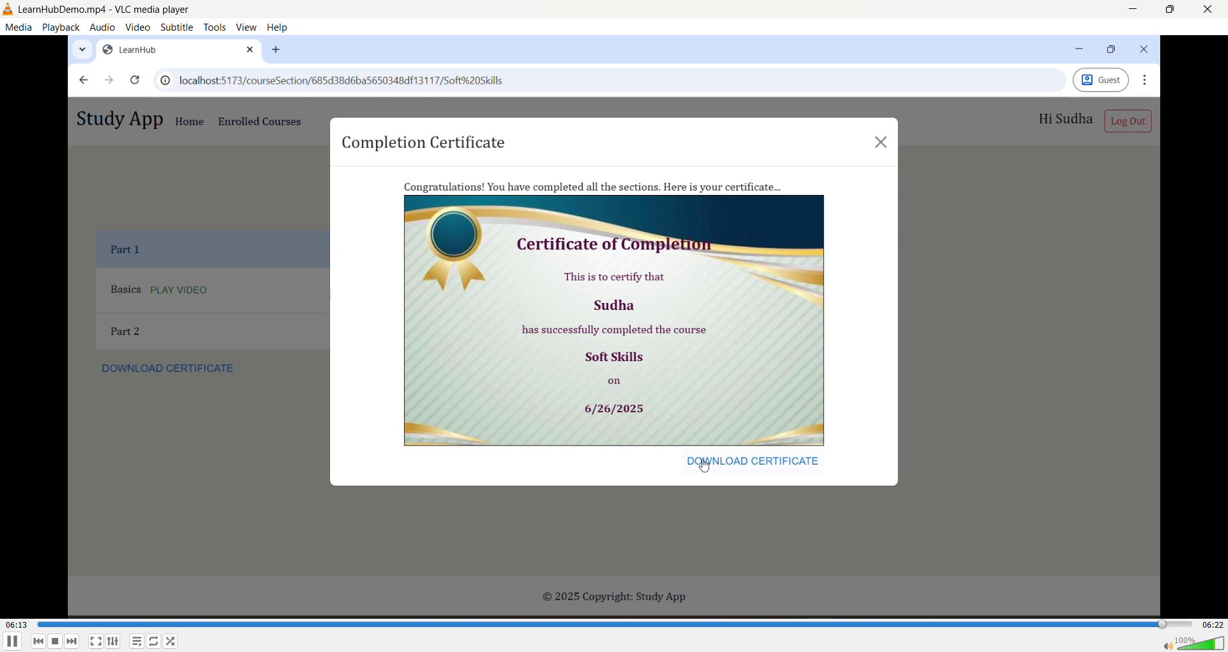

**12. Known Issues**

* Video upload size limitation
* Incomplete multilingual support
* No password reset feature

**13. Future Enhancements**

* Real-time chat between users
* Payment gateway integration
* Mobile app with React Native
* Quizzes and exams
* Analytics and dashboards for educators

**Additional Resources**

* **GitHub Repository:**  
  For source code, issues, and contributions, please visit the official GitHub repository:  
  <https://github.com/LahariGundiga/LearnHub>
* **Project Demo:**  
  To see a working demo of the application, you can access the video demonstration here:  
  <https://drive.google.com/file/d/1rW2WNYv_omVyHJ0nesyiBqp_l2oKosjC/view?usp=sharing>